**LAB 5: PROCESS SCHEDULING ALGORITHMS**

**Abubakar Jamil 10662**

**Q1:**

**Code:**

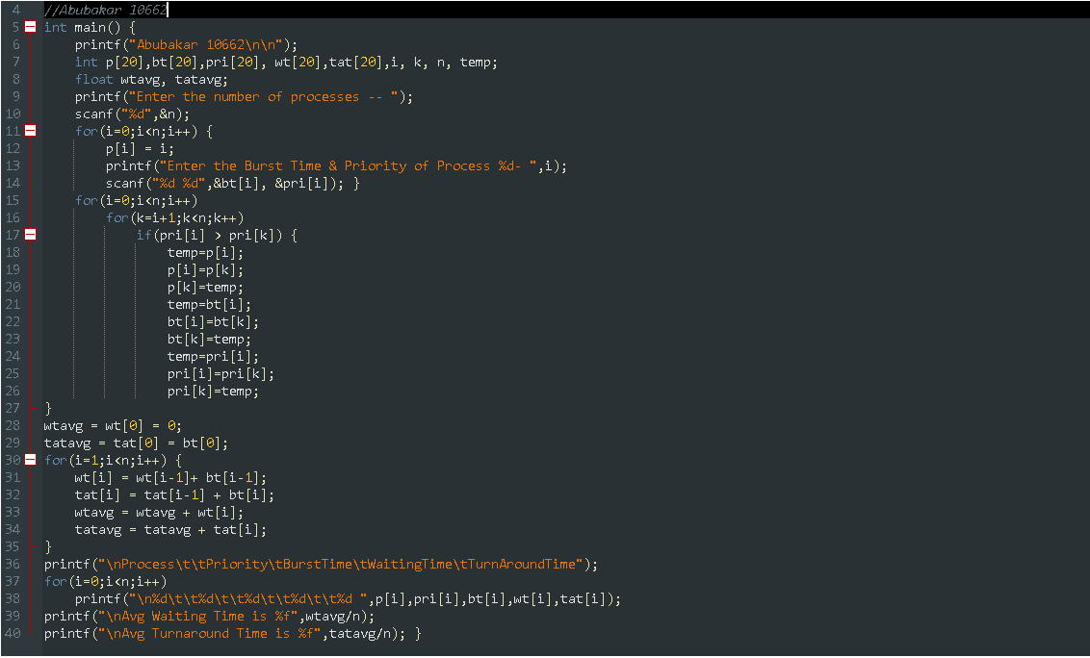

**Output:**

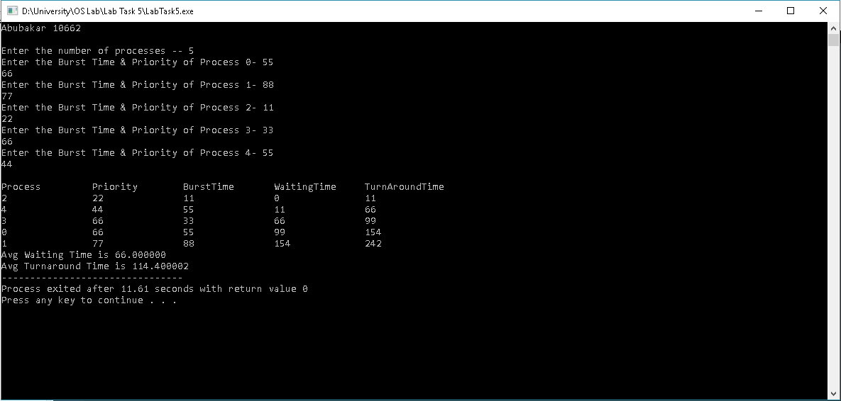

**X--------------------------------X--------------------------------X**

**Q2: Which of the following process scheduling algorithm may lead to starvation?**

a) FIFO.

b) Round Robin.

**c) Shortest Job First.**

d) None of the Above.

**Explanation:**

*Shortest job next may lead to process starvation for processes which will require a long time to complete if short processes are continually added.*